1 Misurina → Dellach

2 Dellach → Villach

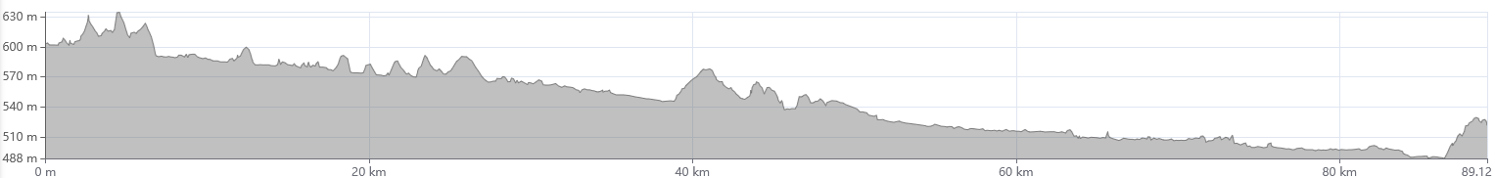

3 Villach → Dullach

4 Dullach → Lavamünd

5 Lavamünd → Maribor

